Unit 6 Math Study Guide- Graphing
Represent and interpret data using tally charts, picture graphs, and bar graphs

Bar graphs:
Johnny asked his friends to vote for their favorite holiday and these are they votes he collected:

Christmas Christmas Valentine’s Day Christmas Thanksgiving Thanksgiving
Valentine’s Day Christmas Thanksgiving Thanksgiving Christmas

Complete the tally chart.
Holiday | Tallies
Christmas
Valentine’s Day
Thanksgiving

Use your tally chart to make a bar graph

5
4
3
2
1
 | Christmas | Valentine’s Day | Thanksgiving
Favorite Holidays

Which holiday had the most votes? __________________________________________________________

Which holiday had the least votes? ___________________________________________________________

How many people voted in all? ______________________________________________________________

Write your own question that someone could answer using the tally chart or graph.

Picture graphs:
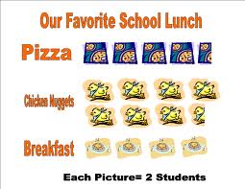
Which school lunch choice do most students like best?

How many students like breakfast best?

How many more students like chicken nuggets than pizza?

How many students voted in all?

Unit 6 Math Study Guide- Money
Know the names and values of a penny, nickel, dime and quarter. Recognize the heads and tails sides.
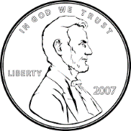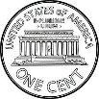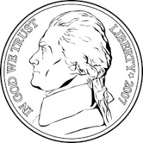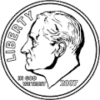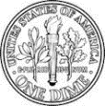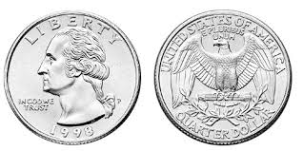
penny= 1¢ nickel = 5¢ dime = 10¢ quarter = 25¢

Count coins with values up to a dollar using combinations of pennies, nickels, dimes and quarters.
- Counting actual coins is a great way to practice.
Show an amount of money in multiple ways.
- 82¢ = Q Q Q N P P OR D D D D D D D D P P
$1
$1
$1
- $3.28= D D D N P P P OR QQQQ QQQQ QQQQ QPPP

Choose the money needed to show equivalent amounts of money.
Which coin is needed to make the two groups equal?
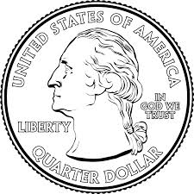 _________

Solve problems involving money. Find change using subtraction.

Sara bought a sandwich for $4. He bought a bag of chips for $2. How much money did he spend?
$4 + $2= $6

Jon bought a soft pretzel for 56¢. He paid with $1.00. How much change did he get back?
9
0 10 10
$1.0 0
- 56¢
44¢

Unit 6 Math Study Guide- Comparing Measurements
Measure length using appropriate tools.
The students will measure with rulers and measuring tapes.
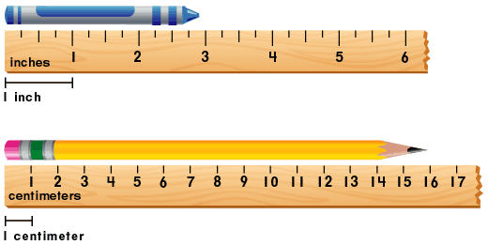
The pencil is 16 centimeters long.
The crayon is 3 inches long.

Compare measurements.
Measure both pencils in centimeters. How much longer is the top pencil?

Estimate length using units of inches and feet.
Which is the best estimate of Which is the best estimate of the
the length of a real desk? length of a real homework folder?

- 1 foot a. 1 foot
- 3 feet b. 3 feet
- 7 feet c. 7 feet
Write and solve addition and subtraction number stories about length
When solving a number story it is important to remember to include a unit and a number sentence in the answer.
Students will need to solve number stories such as:
- Jennifer had 15 yards of fabric. She used 8 yards to make curtains. How many yards of fabric does Jennifer have left?
Answer: 15 - 8= 7 yards

Students will need to write number stories about length to match a diagram.
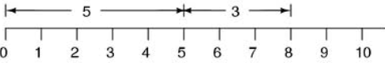
Example: Tom has a piece of duct tape that is 5 inches long. He cut a piece 3 inches long. How much duct tape does he have in all?
Answer: 5+3=8 inches

