Unit 3 Math Study Guide
Place Value concepts to 1,000
Write the number that matches these place value blocks.
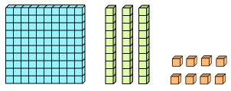= 138 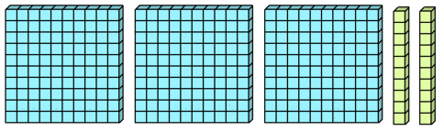= 320
Draw place value blocks to represent a number.
763=

Understand that the three digits of a number represent amounts of hundreds, tens, and ones.
Example: Identify the value of the underlined digit? 952 = 50 329 = 300 176 = 6

Read and write numbers to 1,000 using numerals, number names, and expanded form.
247, two hundred forty-seven, 200 + 40 + 7
508, five hundred eight, 500 + 8

Regroup numbers in different ways.
834= 8 hundreds, 3 tens, 4 ones OR 8 hundreds, 2 tens, 14 ones OR 7 hundreds, 13 tens, 4 ones
75= 7 tesns, 5 ones OR 6 tens, 15 ones OR 5 tens, 25 ones
Skip Count through 1,000 by 2s, 5s, 10s, and 100s.
(Use the pattern in the ones digit to help you keep going. Some students are challenged when you cross into another hundred: 190, 195, 200, 205, 210…)
Examples: Fill in the blanks.
Count by 2s - start at 180, ___, ___, ___,___, ___, ___
Count by 5s- start at 835, ___,___, ___, ___, ___, ___
Count by 10s- start at 760, ___, ___, ___, ___, ___, ___
Count by 100s- start at 400, ___, ___, ___, ___
Compare numbers to 1,000
Write a number that is greater or less than.
Which number is greater than 387? A) 288 B) 392 C) 385
Which number is less than 451? A) 414 B) 520 C) 819

Use >,<, = to compare numbers.
10 ____20 129____117 328____328 642____246

Place numbers in order from least to greatest and greatest to least.
Write the following numbers in order from least to greatest.
32, 17, 58, 160, 113, 327 ____, ____, ____, ____, ____, ____

Write the following numbers in order from greatest to least.
14, 235, 961, 423, 336, 100 ____, ____, ____, ____, ____, ____

