Dear Parents/Guardians,
Over the next several weeks in third grade, we will be learning about Collecting and Displaying Data. Attached is information which outlines what your child will be expected to learn during the unit.

There will be an assessment on this material in about 5 weeks. It would be helpful to review this information with your child at home and allow your child opportunities to read and interpret charts and graphs.

Let us know if you have any questions.

Thanks,
The Third Grade Team

Unit Overview:
In this unit, students apply their knowledge of fractions. They estimate lengths to the nearest halves and fourths of an inch and record that information in bar graphs and line plots. This module also prepares students for the multiplicative comparison problems of grade 4 by asking students “how many more” and “how many less” questions of scaled bar graphs.

Focus Standards:
CC.2.4.3.A.4- Represent and interpret data using tally charts, tables, pictographs, line plots, and bar graphs.
CC.2.4.3.A.1-Solve problems involving measurement and estimation of temperature, liquid volume, mass or length.

Unit Essential Question: How do I generate, use, and interpret various displays of data to solve one and two step problems?

Unit Objective(s):
- Complete a scaled pictograph and a scaled bar graph to represent a data set with several categories (scales limited to 1,2,5, and 10)
- Solve one- and two-step problems using information to interpret data presented in scaled pictographs and scaled bar graphs (scales limited to 1,2, 5, and 10)
- Generate measurement data by measuring lengths using rulers marked with halves and fourths of an inch. Display the data by making a line plot, where the horizontal scale is marked in appropriate units – whole numbers, halves, or quarters
- Translate information from one type of display to another. Limit to pictographs, tally charts, bar graphs, and tables

Important Vocabulary:
Word | What it means | Example
bar graph | A graph drawn using rectangular bars to show how large each value is. The bars can be horizontal or vertical. | 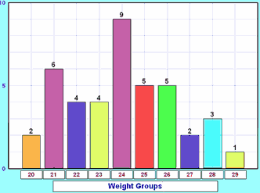http://www.mathsisfun.com/definitions/bar-graph.html
tally chart | A tally chart is a table with tally marks to show a valuable data set. | 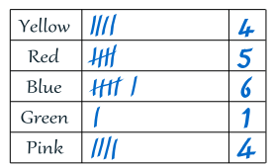  http://www.mathsisfun.com/definitions/bar-gr aph.html
pictograph | A Pictograph is a way of showing data using images. | 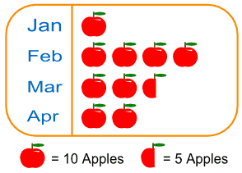  http://www.mathsisfun.com/definitions/bar-gr aph.html
data | Information expressed as numbers | Spelling test scores:  98,95, 75,94
table | A set of facts or figures systematically displayed | Spelling tests scores  Test 1 98  Test 2 95

Example Questions:
1. Paula timed how long some traffic lights stayed red before changing to green. The graph below shows how many seconds the traffic light at each cross street stayed red.
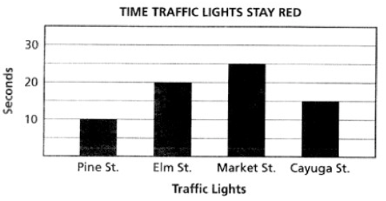
At which cross street is the traffic light red more than 10 seconds but less than 20 seconds?
- (A) Pine St.
- (B) Elm St.
- (C) Market St.
- (D) Cayuga St.

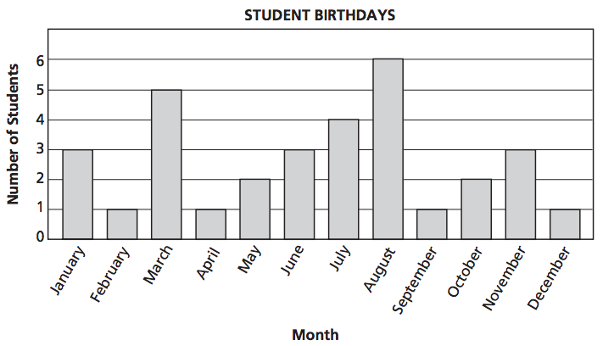
2. Mr. Wright's fourth-grade class made a graph showing the number of student birthdays in each month.

Which statement about the number of student birthdays is true?
- (A) The most birthdays are in March.
- (B) In July, 5 students have birthdays.
- (C) Fewer students have birthdays in October than in June.
- (D) More students have birthdays in June than in November.

