Dear Parents/Guardians,
Over the next several weeks in Third Grade, we will be learning about Fractions. Attached is information which outlines what your child will be expected to learn during the unit.

There will be an assessment on this material in about six weeks. It would be helpful to review this information with your child at home and allow your child opportunities to work with measuring cups or spoons, divide items into equal parts and determine the fraction for one piece of the whole.

Let us know if you have any questions.

Thanks,
The Third Grade Team

Unit Overview:
The goal of this unit is for students to transition from thinking of fractions as parts of a figure to points on a number line. To make that jump, students think of fractions as being constructed out of unit fractions: “1 fourth” is the length of a segment on the number line such that the length of four concatenated fourth segments on the line equals 1 (the whole). Once the unit “1 fourth” has been established, counting them is as easy as counting whole numbers: 1 fourth, 2 fourths, 3 fourths, 4 fourths, 5 fourths, etc. Students also compare fractions, find equivalent fractions in special cases, and solve problems that involve comparing fractions.

Focus Standard Addressed in this Module:
CC.2.1.3.C.1 Explore and develop an understanding of fractions as numbers.

Unit Essential Question:
How do we demonstrate understanding of fractions to represent them on a number line? How can we recognize and generate equivalent fractions? How can we compare fractions?
Unit Objective(s):
- Demonstrate that when a whole or set is partitioned into y equal parts, the fraction 1/y represents 1 part of the whole and/or the fraction x/y represents x equal parts of the whole (limit the denominators to 2,3,4,6,and 8; limit numerators to whole numbers less than the denominator; no simplification necessary)
- Represent fractions on a number line (limit the denominators to 2,3,4,6, and 8; limit numerators to whole numbers less than the denominator; no simplification necessary)
- Recognize and generate simple equivalent fractions (limit the denominators to 1,2,3,4,6, and 8; limit numerators to whole numbers less than the denominator)
- Express whole numbers as fractions, and/or generate fractions that are equivalent to whole numbers (limit the denominators to 1,2,3,4,6,and 8; limit numerators to whole numbers less than the denominator)
- Compare two fractions with the same denominator (limit the denominators to 1,2,3,4,6,and 8), using the symbols >, =, or
- Round two- and three-digit whole numbers to the nearest ten or hundred, respectively
- Add two- and three-digit whole numbers (limit sums from 100 through 1,000), and/or subtract two- and three-digit numbers from three-digit whole numbers.

Important Vocabulary:
Word | What it means | Example
Equal parts | Shapes or groups divided into equal sizes
Part and Whole | Whole is the entire shape or group. Part is the portion being counted. | xxxy The whole is the set of 4 letters. The parts are the three x and the one y.
Equivalent Fractions | Two fractions that represent the same size or amount. | 2/4=1/2
Number Line | A line with numbers placed in their correct positions. | 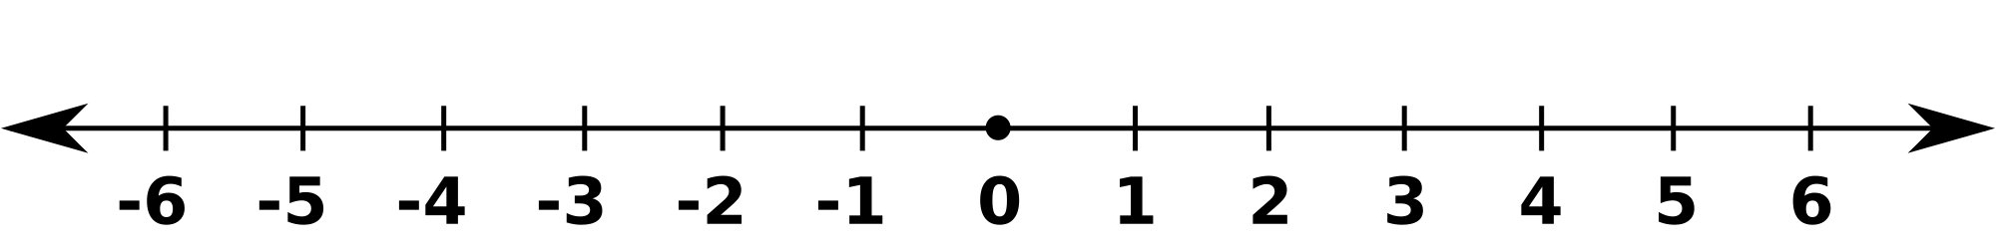
Numerator | Top numeral in a fraction, showing what portion of the whole is being counted. | Ex: ¾ 3 is the numerator  xxxy ¾ of the letters are x
Denominator | Bottom numeral in a fraction, showing how many equal pieces make the whole. | Ex. ¾ 4 is the denominator  xxxy there are 4 letters in the group

Example Questions:
Anna drew the butterflies shown below.
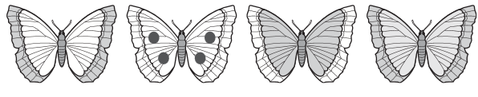
What fraction of the set of butterflies has dots ?
- (A) (B) (C) (D)

Which statement is an example of the fraction ?
- (A) In Jake’s fish tank, 1 of his 3 fish is a goldfish.
- (B) In Jake’s fish tank, 1 of his 4 fish is a goldfish.
- (C) Jake has 3 fish that he feeds 2 times a day.
- (D) Jake has 1 fish that he feeds 4 times a day.

Anna placed candles on of the set of cupcakes shown below.
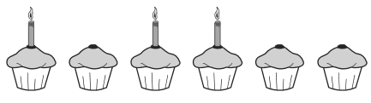
Which fraction is equivalent to ?
- (A) (B) (C) (D)

