Dear Parents/Guardians,
Over the next several weeks in third grade, we will be learning about Multiplication and Area. Attached is information which outlines what your child will be expected to learn during the unit.

There will be an assessment on this material in about 4 weeks. It would be helpful to review this information with your child at home and practice finding the area and perimeter of rectangles with your child.
Let us know if you have any questions.

Thanks,
The Third Grade Team

Unit Overview:
This unit investigates the area and formula for area of a rectangle. Students will begin by measuring the area of a shape by finding the number of same-size units of area required to cover the shape without gaps or overlaps. Students will then measure the area by multiplying the length and width. Students will also find the perimeter of rectangles by adding the measures of all sides in the shape.

Focus Standards:
CC.2.4.3.A.5 - | Determine the area of a rectangle and apply the concept to multiplication and to addition.

Unit Essential Question:
How do we find the area and perimeter of a rectangle using multiplication and addition?

Unit Objective(s):
At the end of this unit, students will be able to independently use their learning to:
- Measure areas by counting unit squares (square centimeter, square meter, square inch, square foot, and non-standard units)
- Multiply side lengths to find areas of rectangles with whole-number side lengths in the context of solving real-world and mathematical problems, and represent whole-number products as rectangular areas in mathematical reasoning.

Important Vocabulary:
Word | What it means | Example
length | Measure of a side of a shape | Length
width | Measure of a side of a shape
area | The amount of space something takes up. In a rectangle, it is the result of multiplying length by width.. | A = l x w  A = 2 inches x 4 inches  A = 8 sq. inches
perimeter | The total distance, or length, around a shape. It is found by adding all the sides. | P = s + s + s + s  P = 2 in. + 4 in. + 2 in. + 4 in.  P = 12 inches

Example Problems:

1. Find the area of the sandbox below.
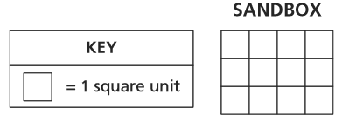
- 7 (B) 10 (C) 12 (D) 14

2. Find the perimeter of the rectangle below.
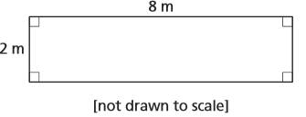
- 8 meters (B) 10 meters (C) 16 meters (D) 20 meters

