Unit 7 Math Study Guide
Analyze and draw 2 dimensional shapes.
*Know how many sides and vertices (corners) they have.
*Be able to compare and contrast them.

triangle rectangle pentagon

hexagon circle square parallelogram

Analyze and build 3 dimensional shapes.
* Know how many faces, edges, and vertices they have.
* Be able to compare and contrast them.
edge vertex

face

cylinder cube rectangular prism
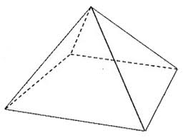
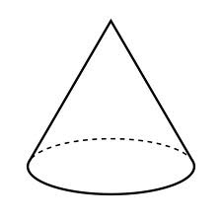

cone sphere pyramid
Divide a shape into equal parts and describe the parts using halves, thirds, and fourths

This rectangle is divided This circle is divided Partition this shape into Partition this shape into
into fourths. into halves. fourths. Color two fourths. thirds. Color one third.

